**Azure Storage Account Automation**

1. **Pre-Requisites- App Registration and Settings**
   1. Register an App as per below screenshots over Azure Portal.

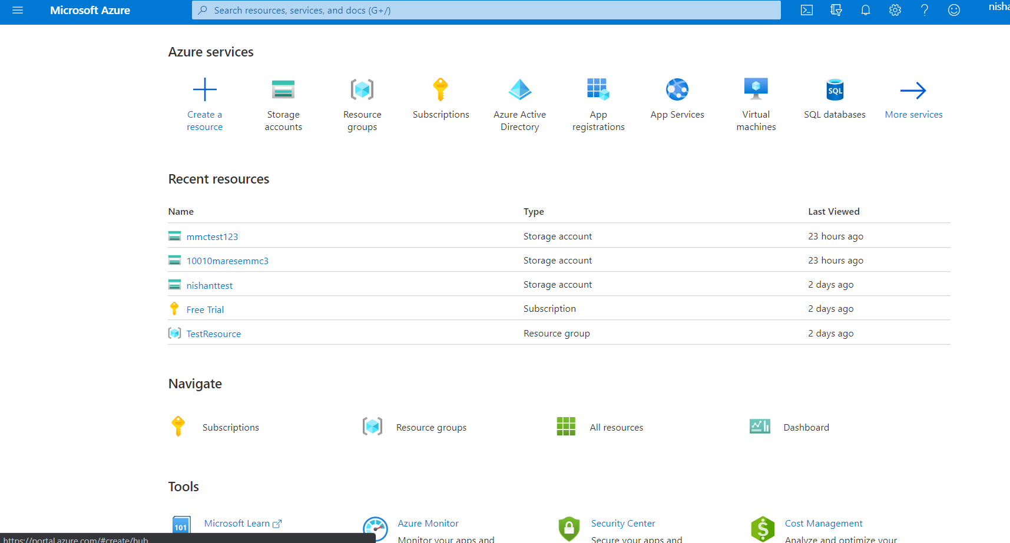

* + - 1. Click on New Registration

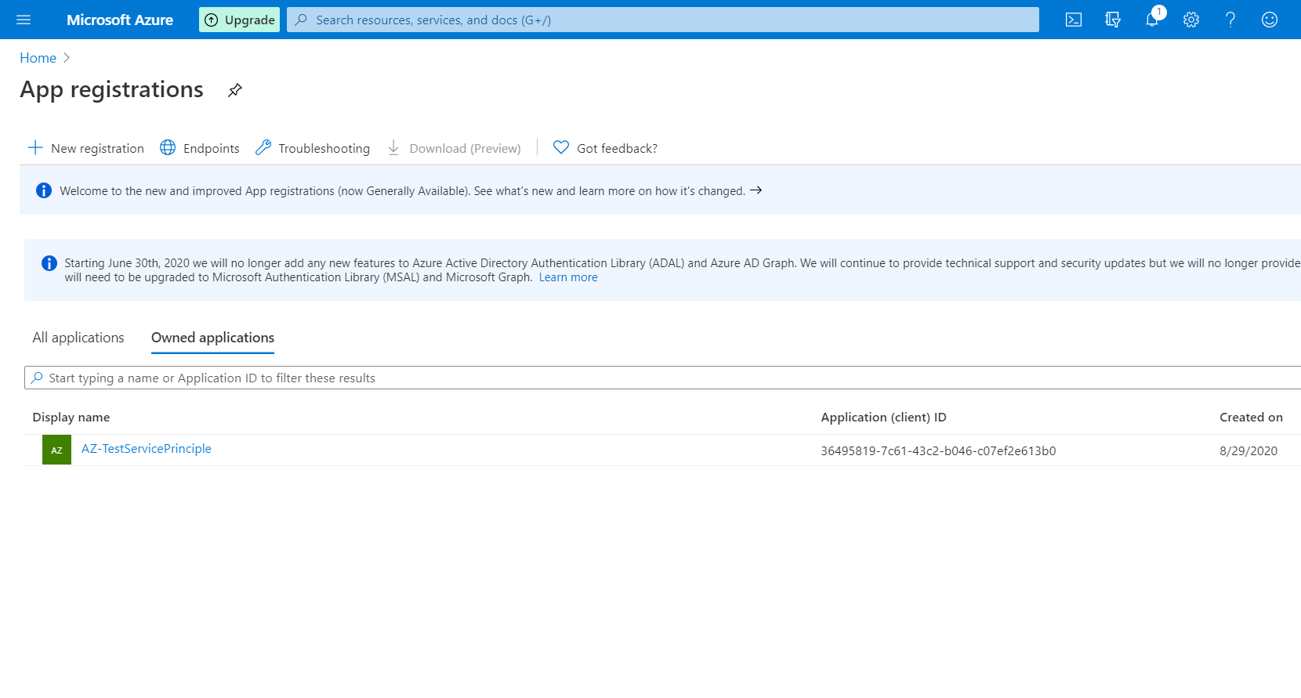

* + - 1. Fill the details as per below

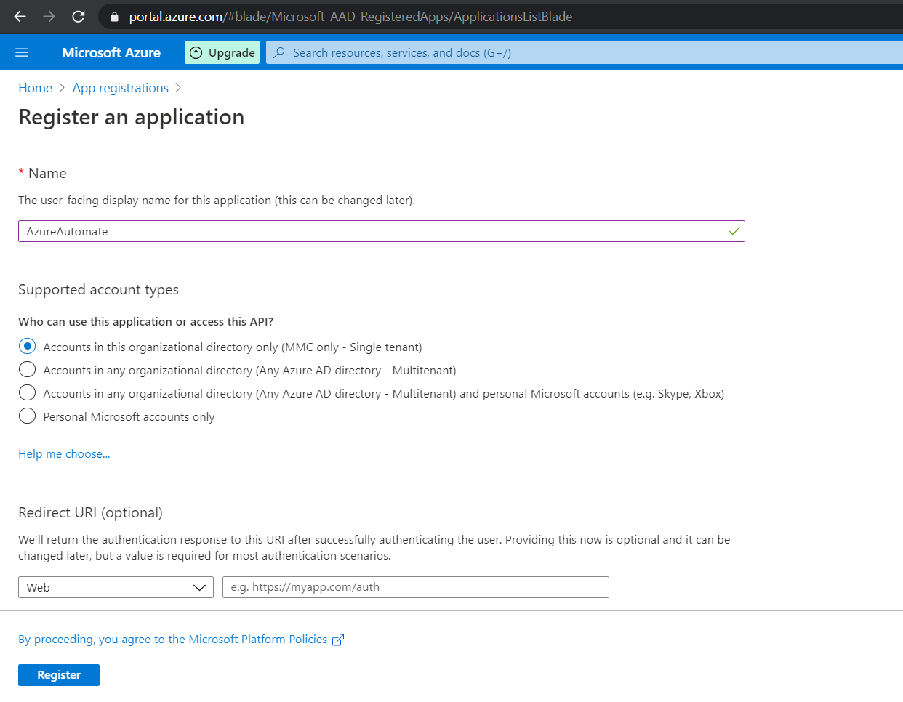

* + - 1. App is registered and it will show the basic details as below. Now click Certificates & Secrets.

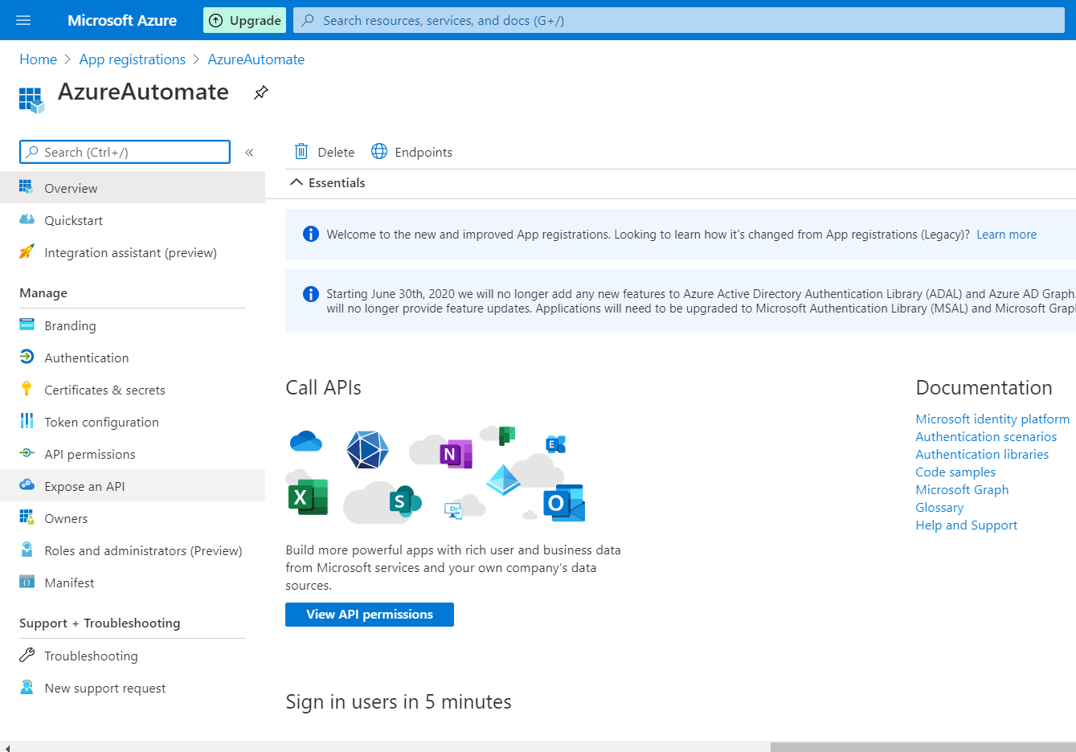

* + - 1. Click on New Client Secret and Fill the description. Set Expires to Never and click on Add.

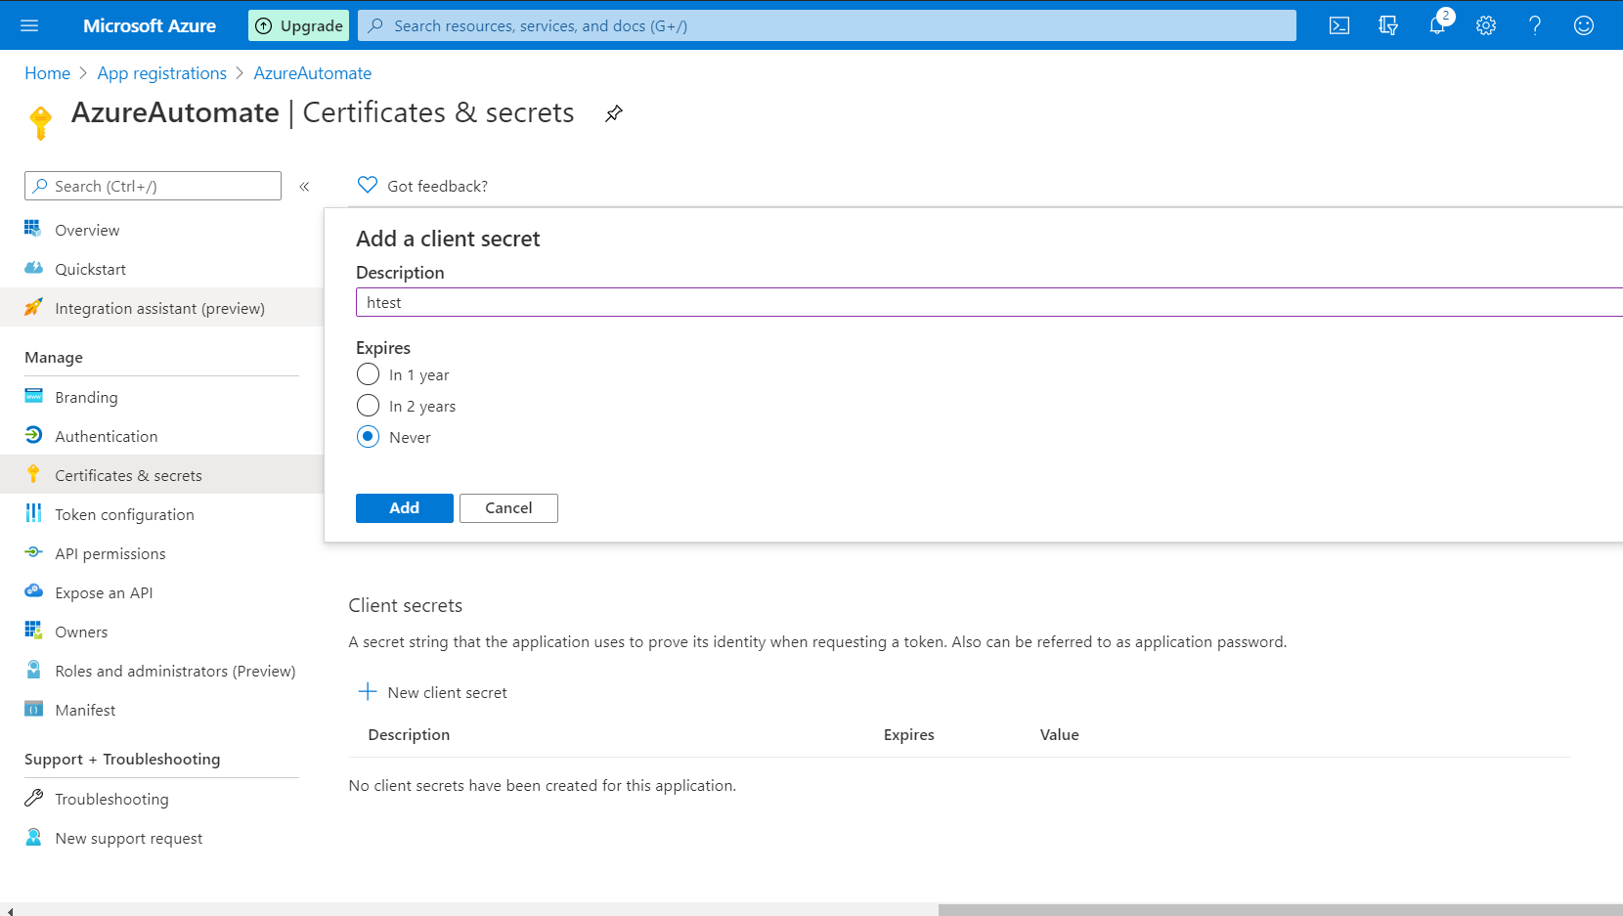

* + - 1. Copy the Client Secret Key and paste it in the JSON file of API.

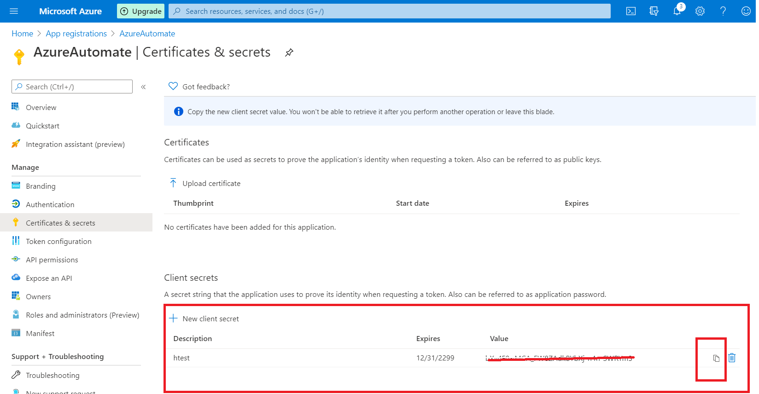

* + - 1. Get the Application Id as Client Id and TenantId from Overview Tab of registered app.
      2. Go to Subscriptions as per below.

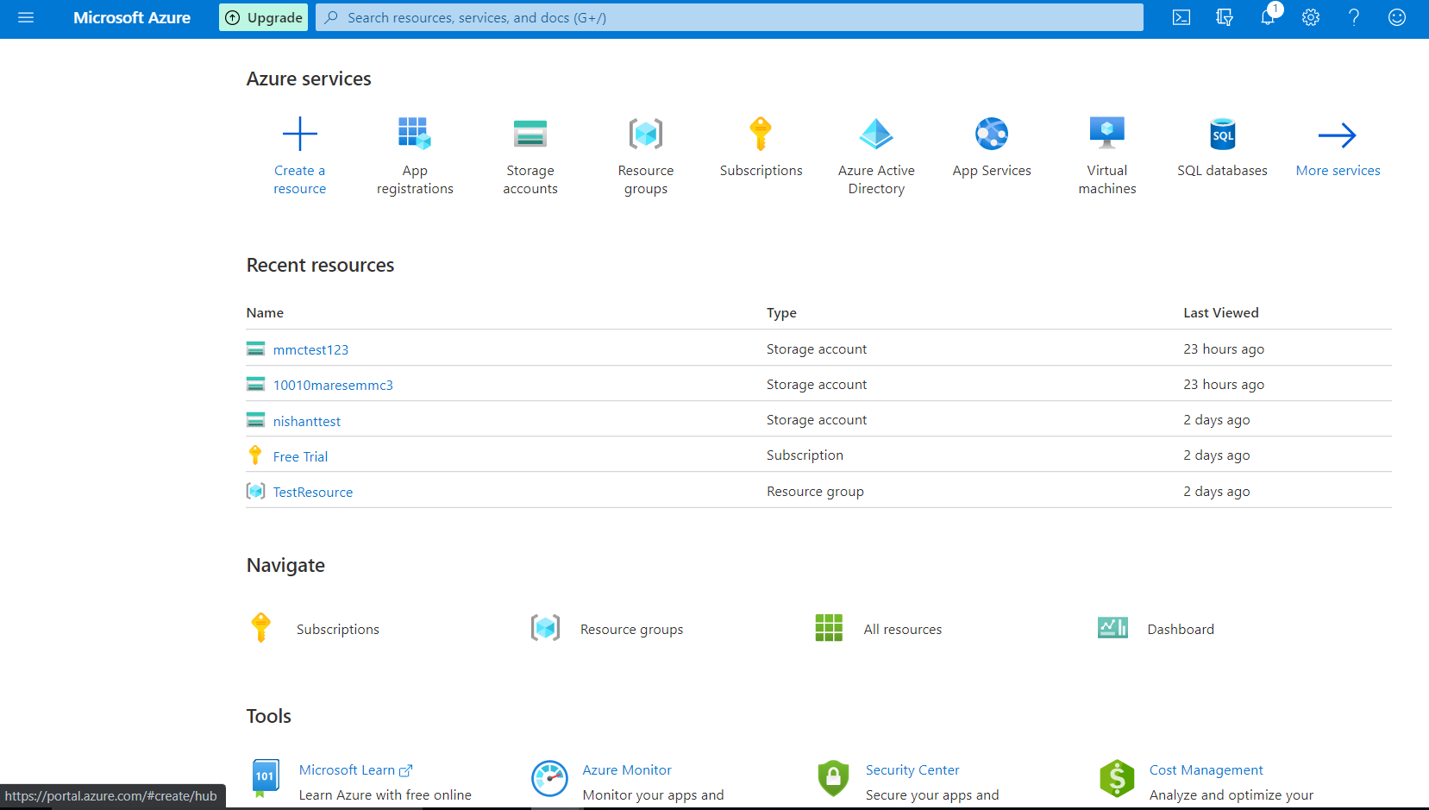

* + - 1. Choose your subscription and then go to Access Control (IAM) and click on Add Role Assignment.

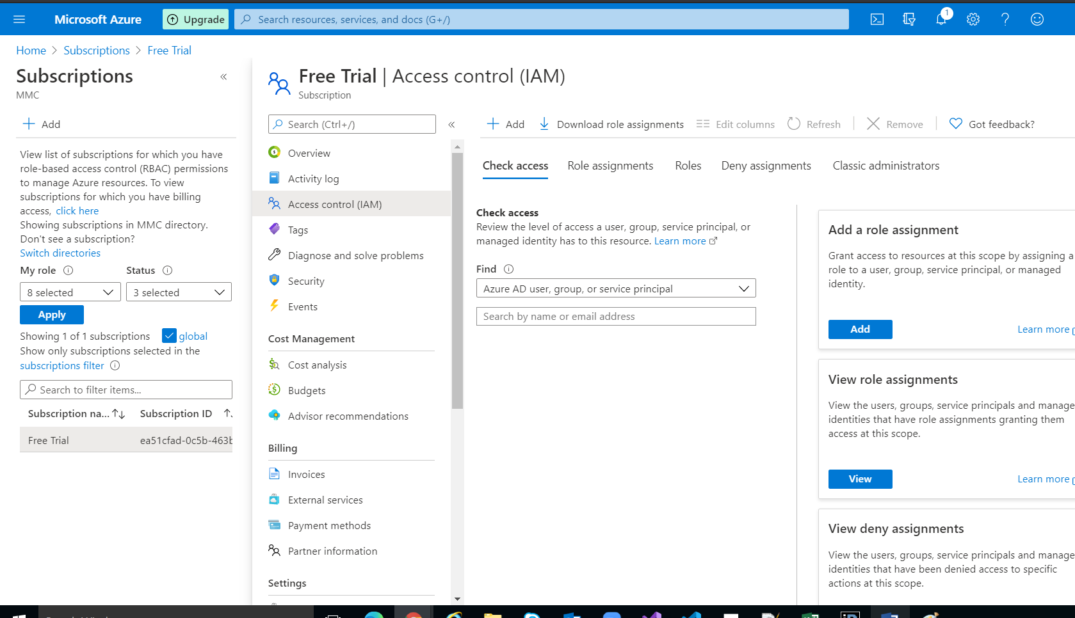

* + - 1. Choose Role->Contributor, Assign Access to-> Azure AD user, group, or service principal (default option), Select-> Search for the registered App we created above.

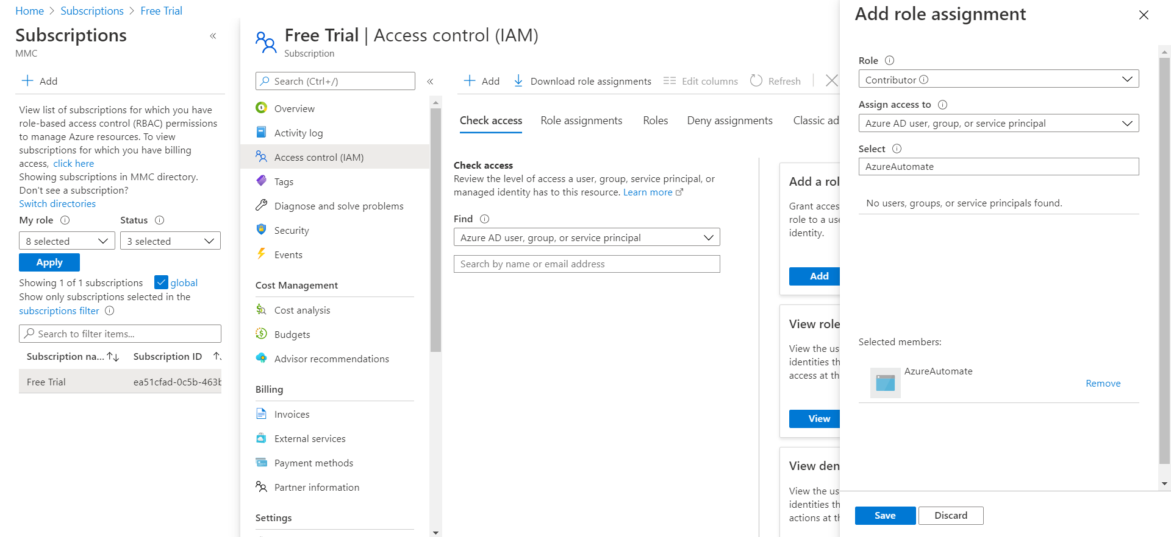

* + - 1. Verify the roles are added under Role Assignments.

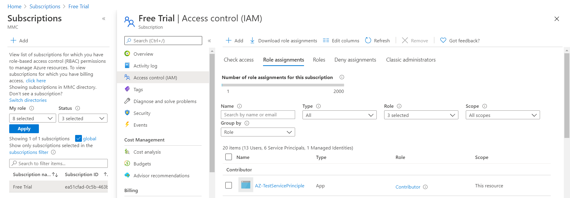

* + - 1. Go to Resource Providers and search for Microsoft.Storage and Registers it if it is not shown as registered.

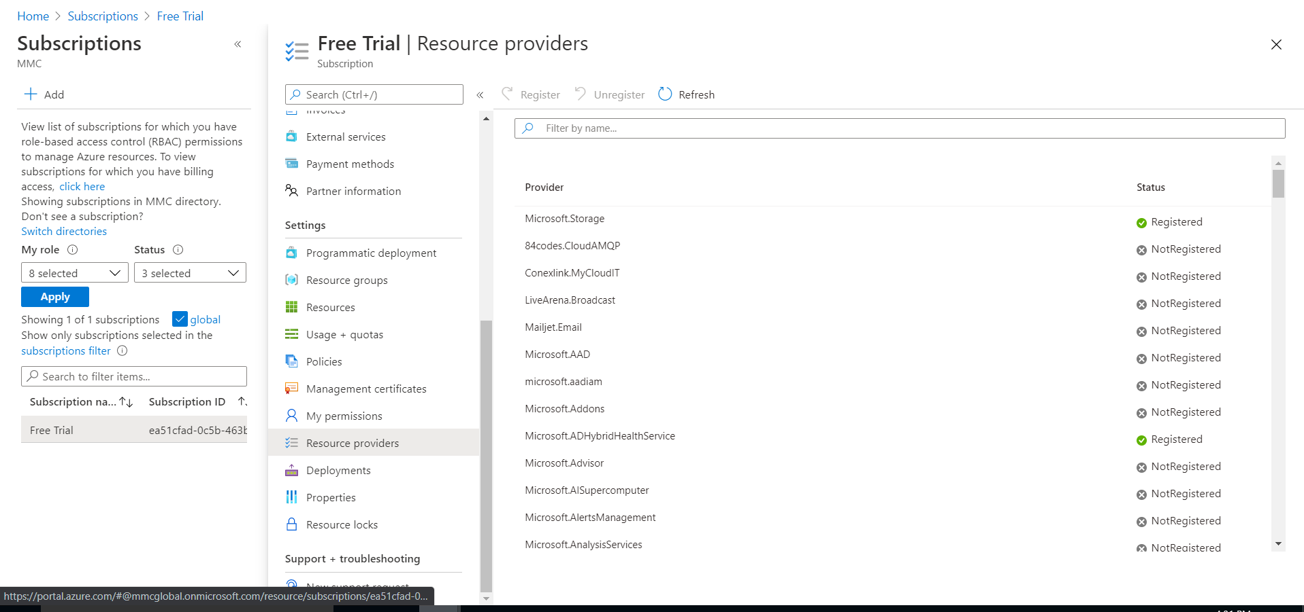

1. Tables-
   1. **DMSServiceInfo**

**This table is used for taking the details to create the Azure Storage account. Details used are as below-**

AccountName= DatabaseName+Prefix of DMSTenantURL

Tags= AccountName

Schema Details as below-

|  |  |  |  |
| --- | --- | --- | --- |
| **Column** | **Data Type** | **Nullable** | **Usage** |
| Id | Int | No | Auto Increment |
| TenantId | Uuid | No | Input from frontend |
| DatabaseServer | Text | No | Input from frontend |
| DatabaseUser | Text | No | Input from frontend |
| DatabasePassword | Text | No | Input from frontend |
| DatabaseName | Text | No | Input from frontend |
| DatabasePort | Text | No | Input from frontend |
| DMSTenantURL | Text | Yes | Input from frontend |
| AzStorageConnectionString | Text | Yes | Connection String created after account creation |
| AzStorageContainer | Text | Yes | AccountName used to create StorageAccount |
| IsDbProvisioned | Boolean | No | Input from frontend |
| Location | Text | No | Location used to create Account- Input from frontend |
| IsReplication | Boolean | No | It depicts whether LRS or GRS. True indicates GRS. |
| IsDeleted | Boolean | No | It describes whether the account is deleted or not on the basis of Account Name. |

* 1. **StorageAccounts**

**This table stores all the account properties of storage account created.**

Schema Details as below-

|  |  |  |  |
| --- | --- | --- | --- |
| **Column** | **Data Type** | **Nullable** | **Usage** |
| Id | Int | No | Auto Increment |
| DMSServiceInfoId | Int | No | Parent Id of DMSService Info |
| AccountName | Text | No |  |
| AccountType | Text | No |  |
| AccountId | Text | No |  |
| Kind | Text | No |  |
| SkuName | Text | No |  |
| BlobEndPoints | Text | Yes |  |
| QueueEndPoints | Text | Yes |  |
| FileEndPoints | Text | Yes |  |
| TableEndPoints | Text | No |  |
| PrimaryLocation | Text | No |  |
| CreationTime | DateTime | No |  |
| LargeFileSharesState | Text | No |  |
| AccessTier | Text |  |  |
| KeySource | Text |  |  |
| IsHnsEnabled | Boolean |  |  |
| EnableHttpsTrafficOnly | Boolean |  |  |
| AllowBlobPublicAccess | Boolean |  |  |
| MinimumTlsVersion | Text |  |  |
| TagKey | Text |  |  |
| TagValue | Text |  |  |
| Location | Text |  |  |
| KeyAccessName | Text |  |  |
| KeyAccessValue | Text |  |  |

* 1. **ExceptionLogs**

**This table contains the exception logs if any.**

1. Settings in Json file-

Provide the values in json file of API to proceed.

"AppSettings": {

"resourceGroupName": "smartdi_storage",

"clientSecretKey": "",

Provide the Application Secret key generated above in 5th point.

"subscriptionId": "",

Provide the Subscription Id from Subscriptions screen of Azure

"clientId": "",

Provide the Application Id generated after App registration

"tenantId": "",

Provide the Tenant Id. Can be taken from Overview screen of App Registered.

"authURL": "https://login.windows.net/",

Do not change

"azureManagementURL": “<https://management.azure.com/>”

Do not change

},